* Install Power BI Desktop and share the final screenshot of the report view page

which appears when power desktop starts.

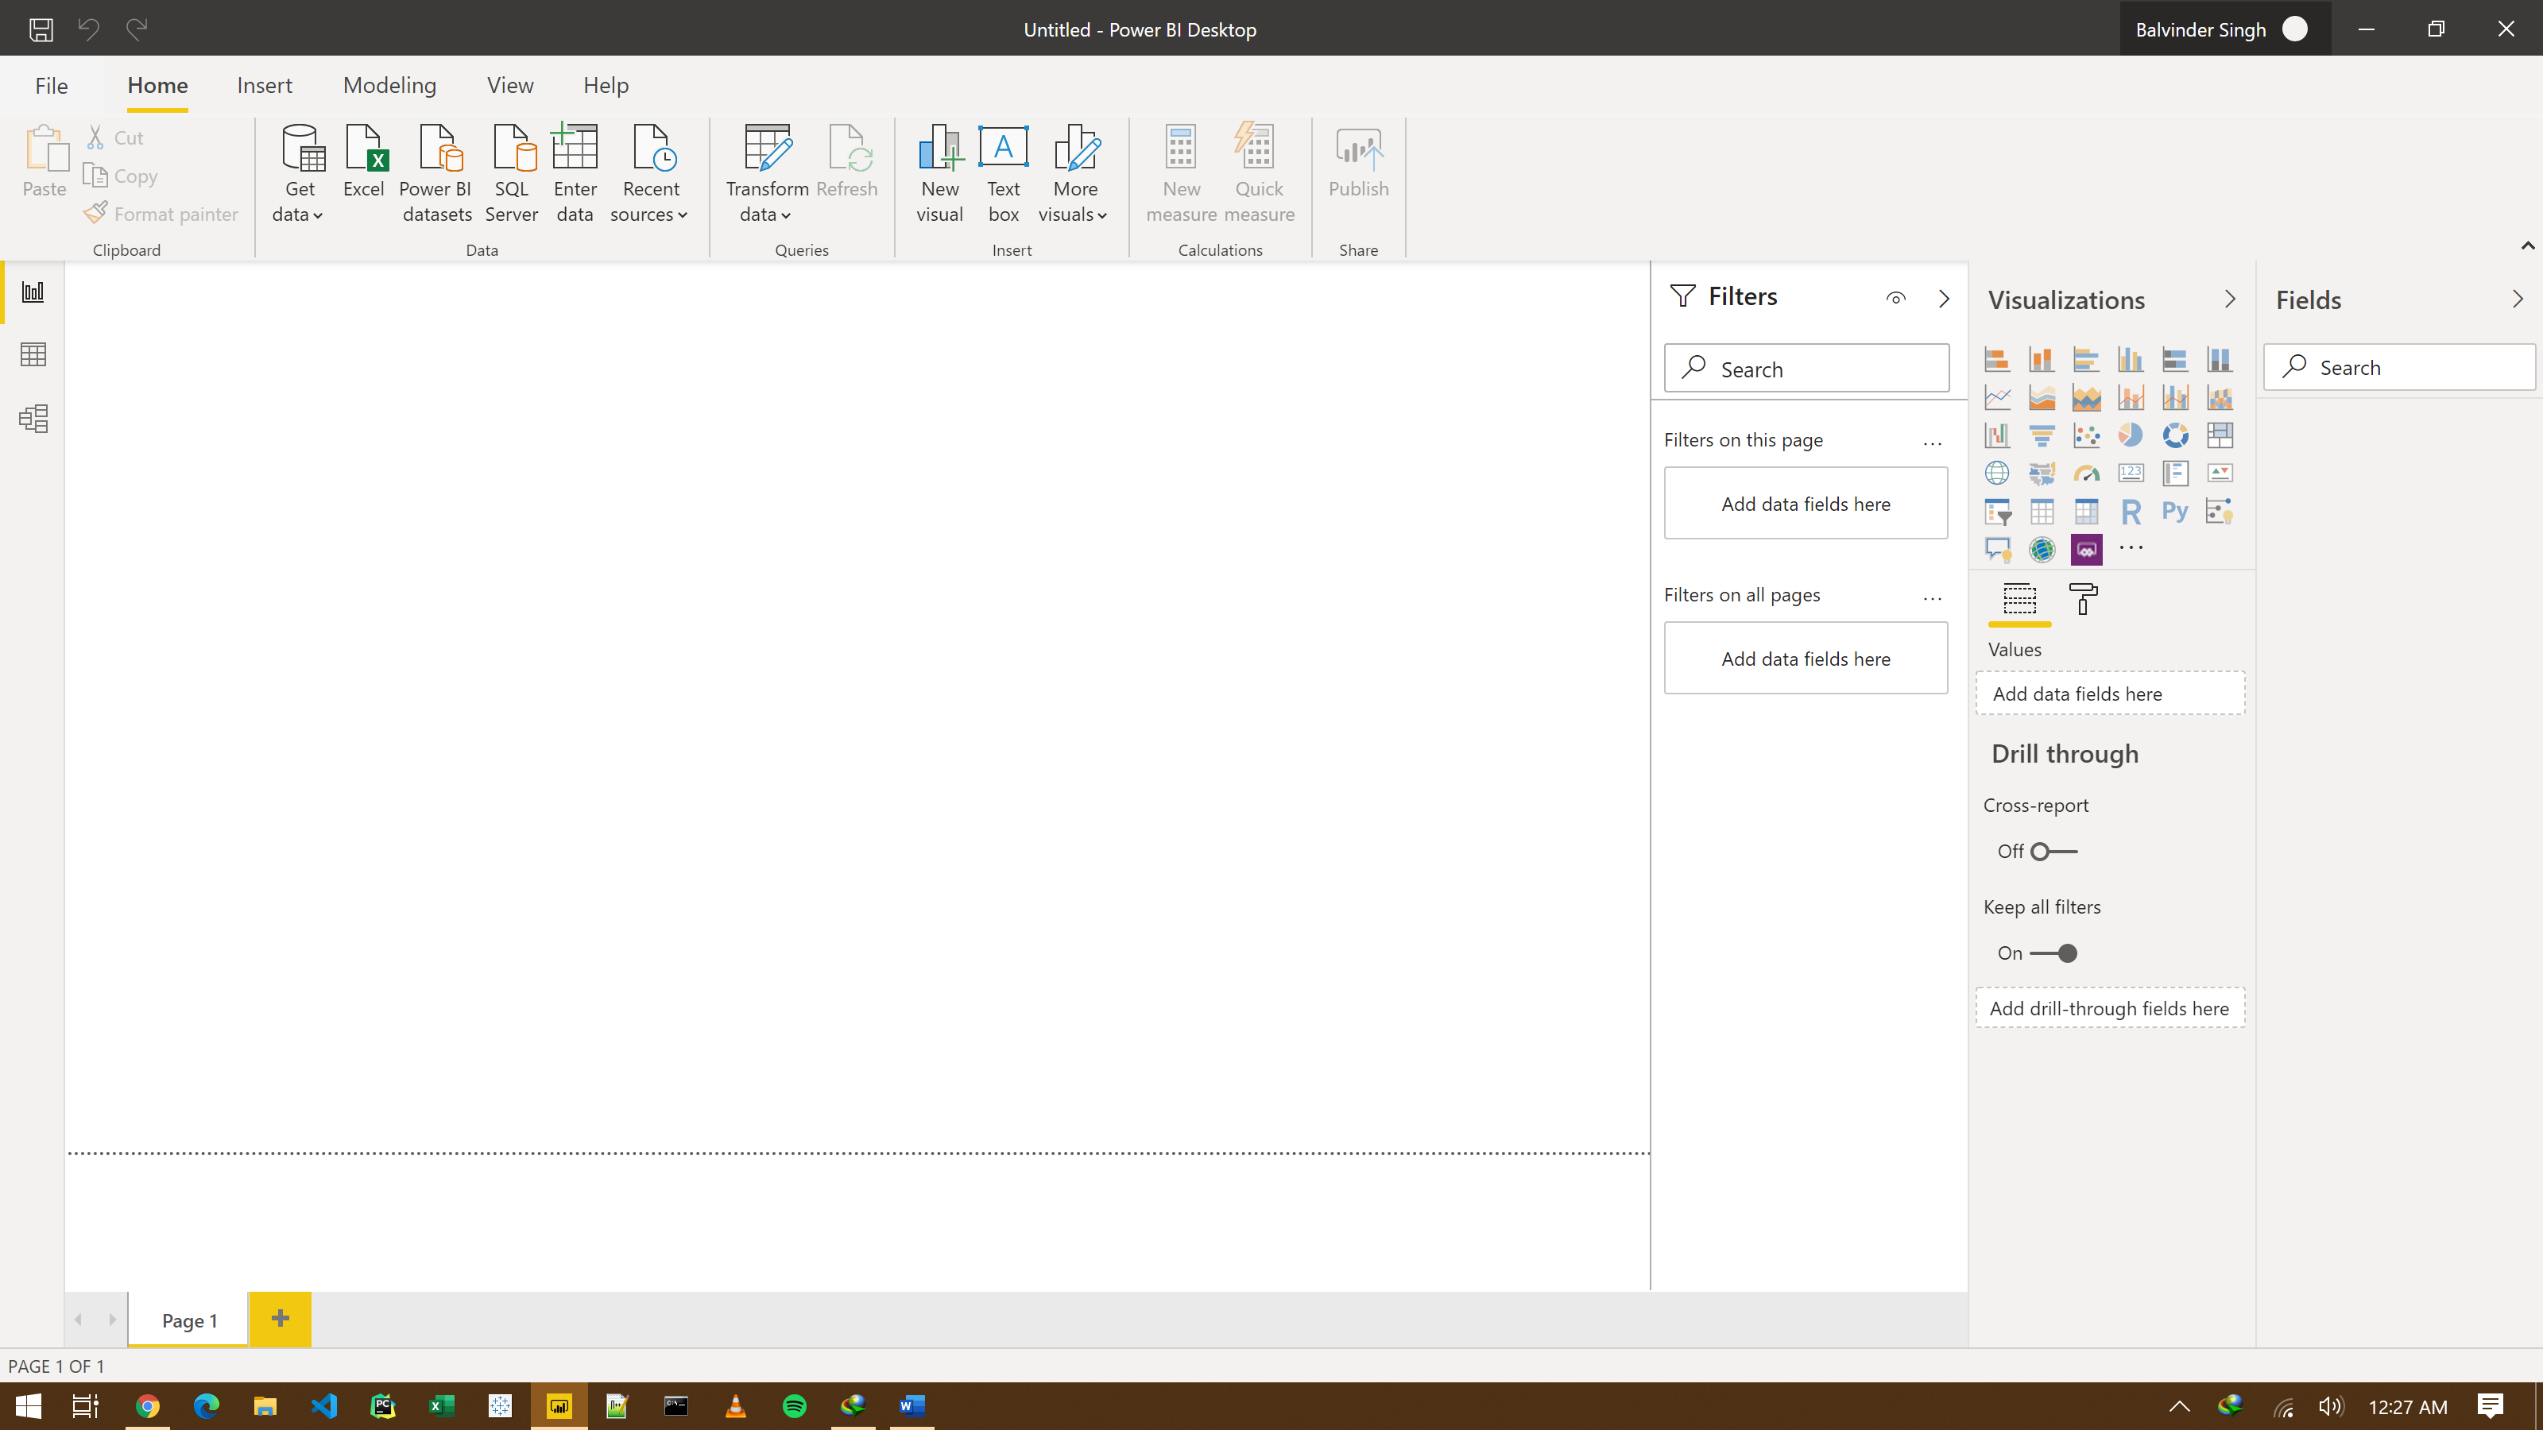

* Prepare a document and with the following screenshot

− Report View

− Data View

− Model View

− Power Query Editor

− Advance Editor

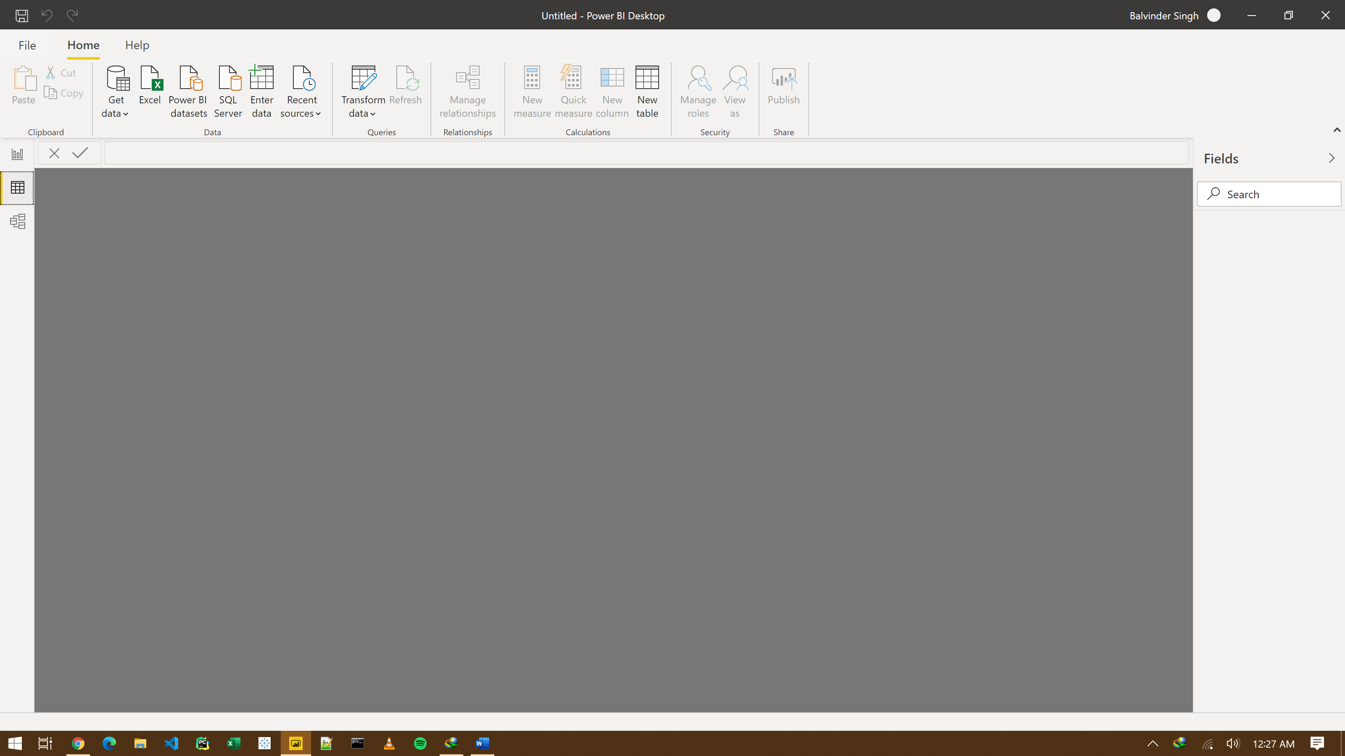

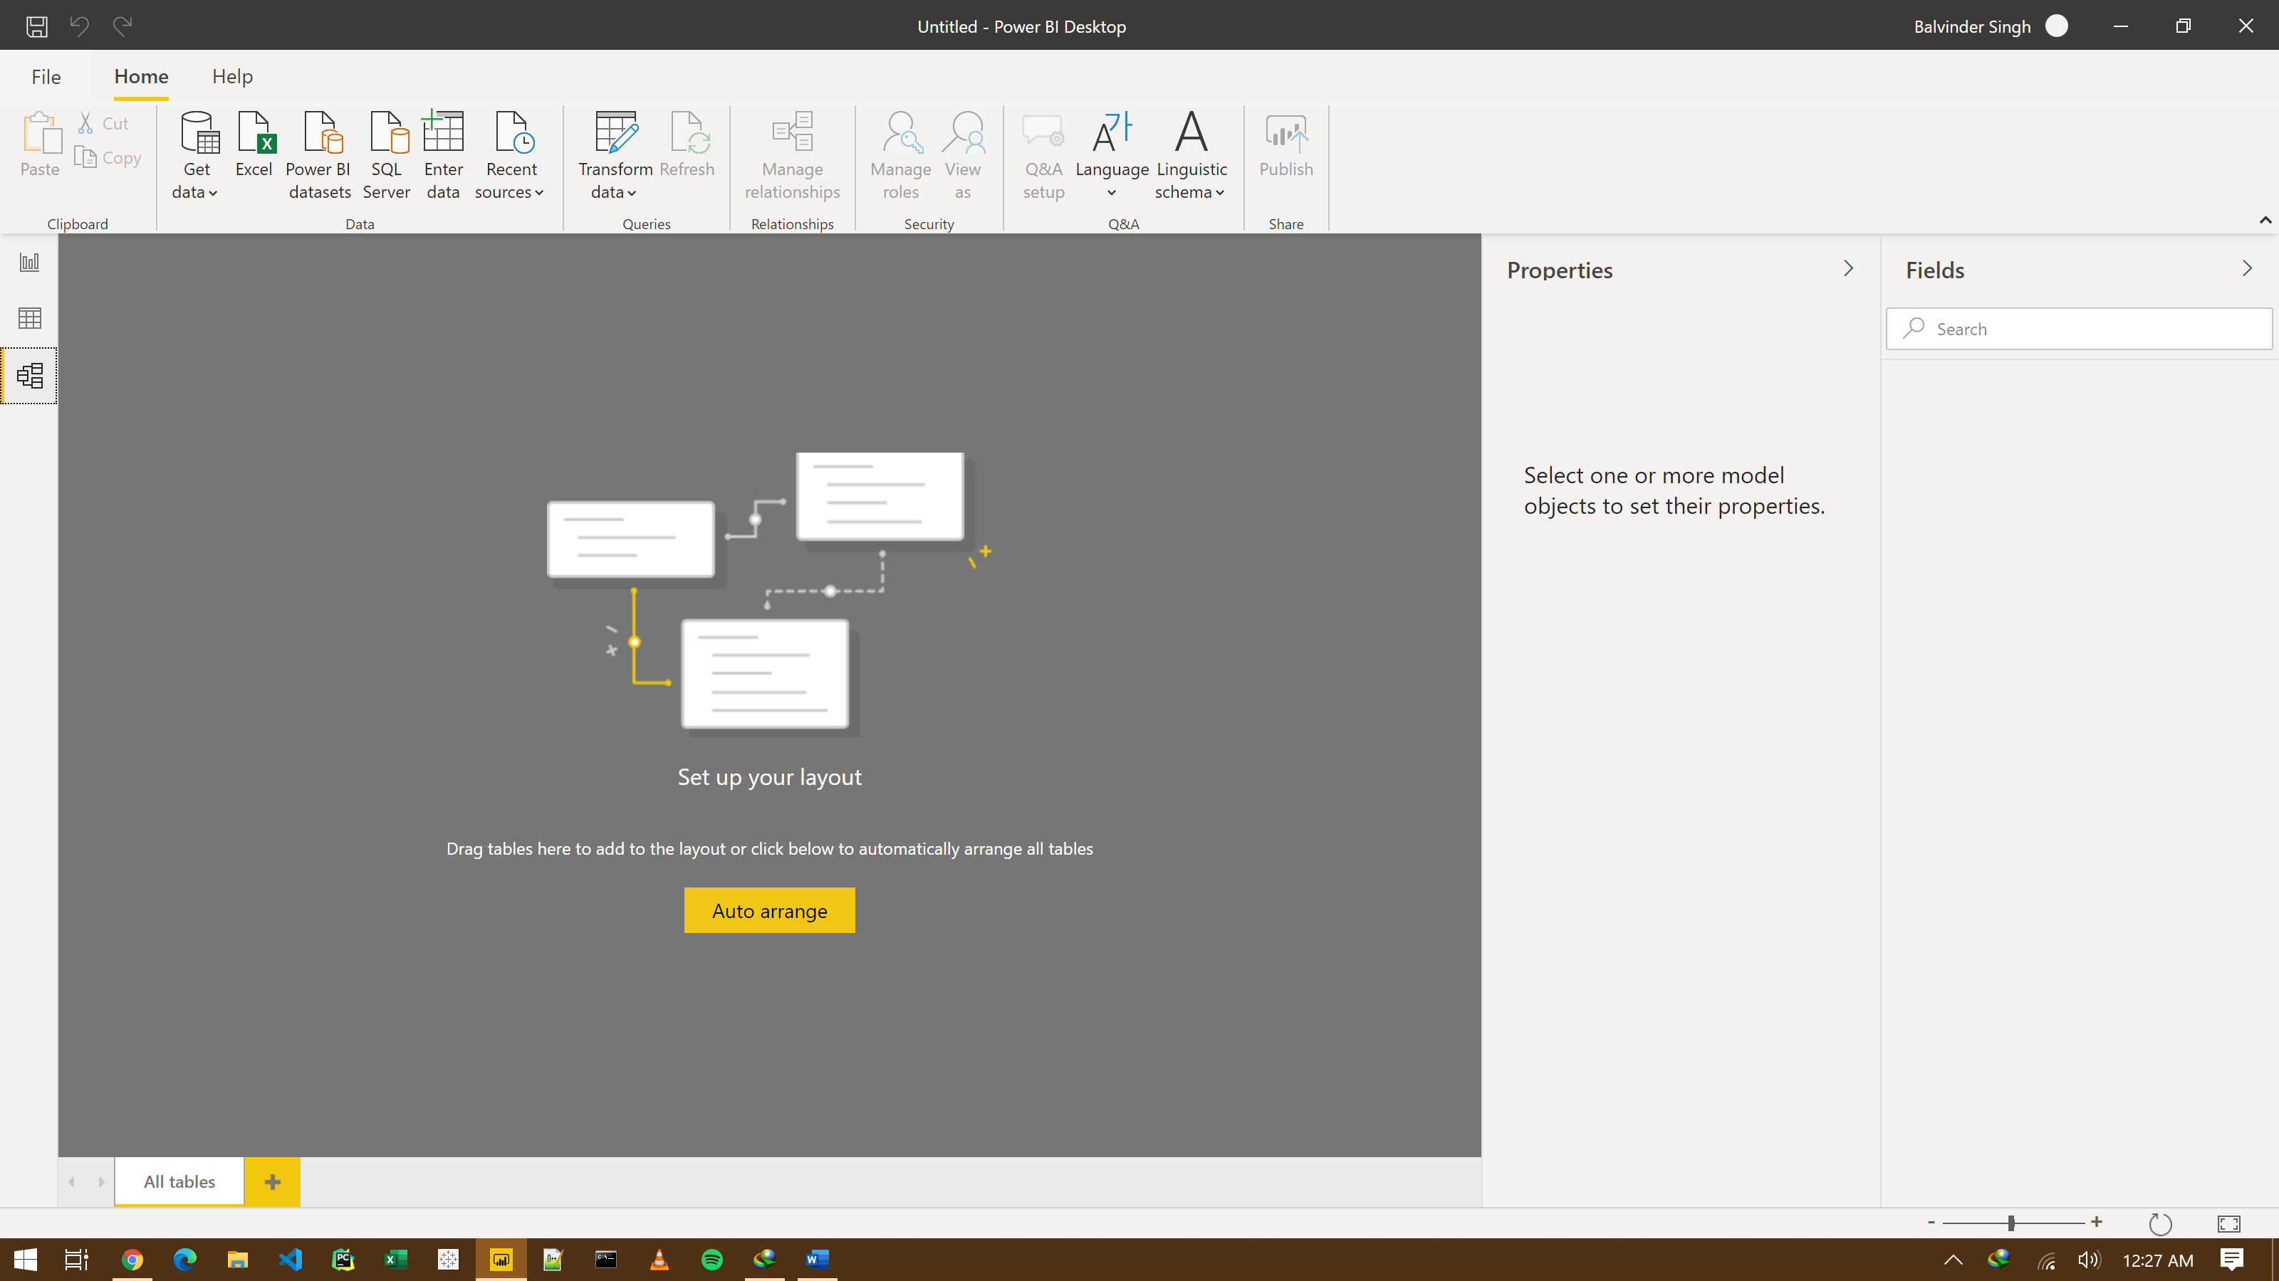

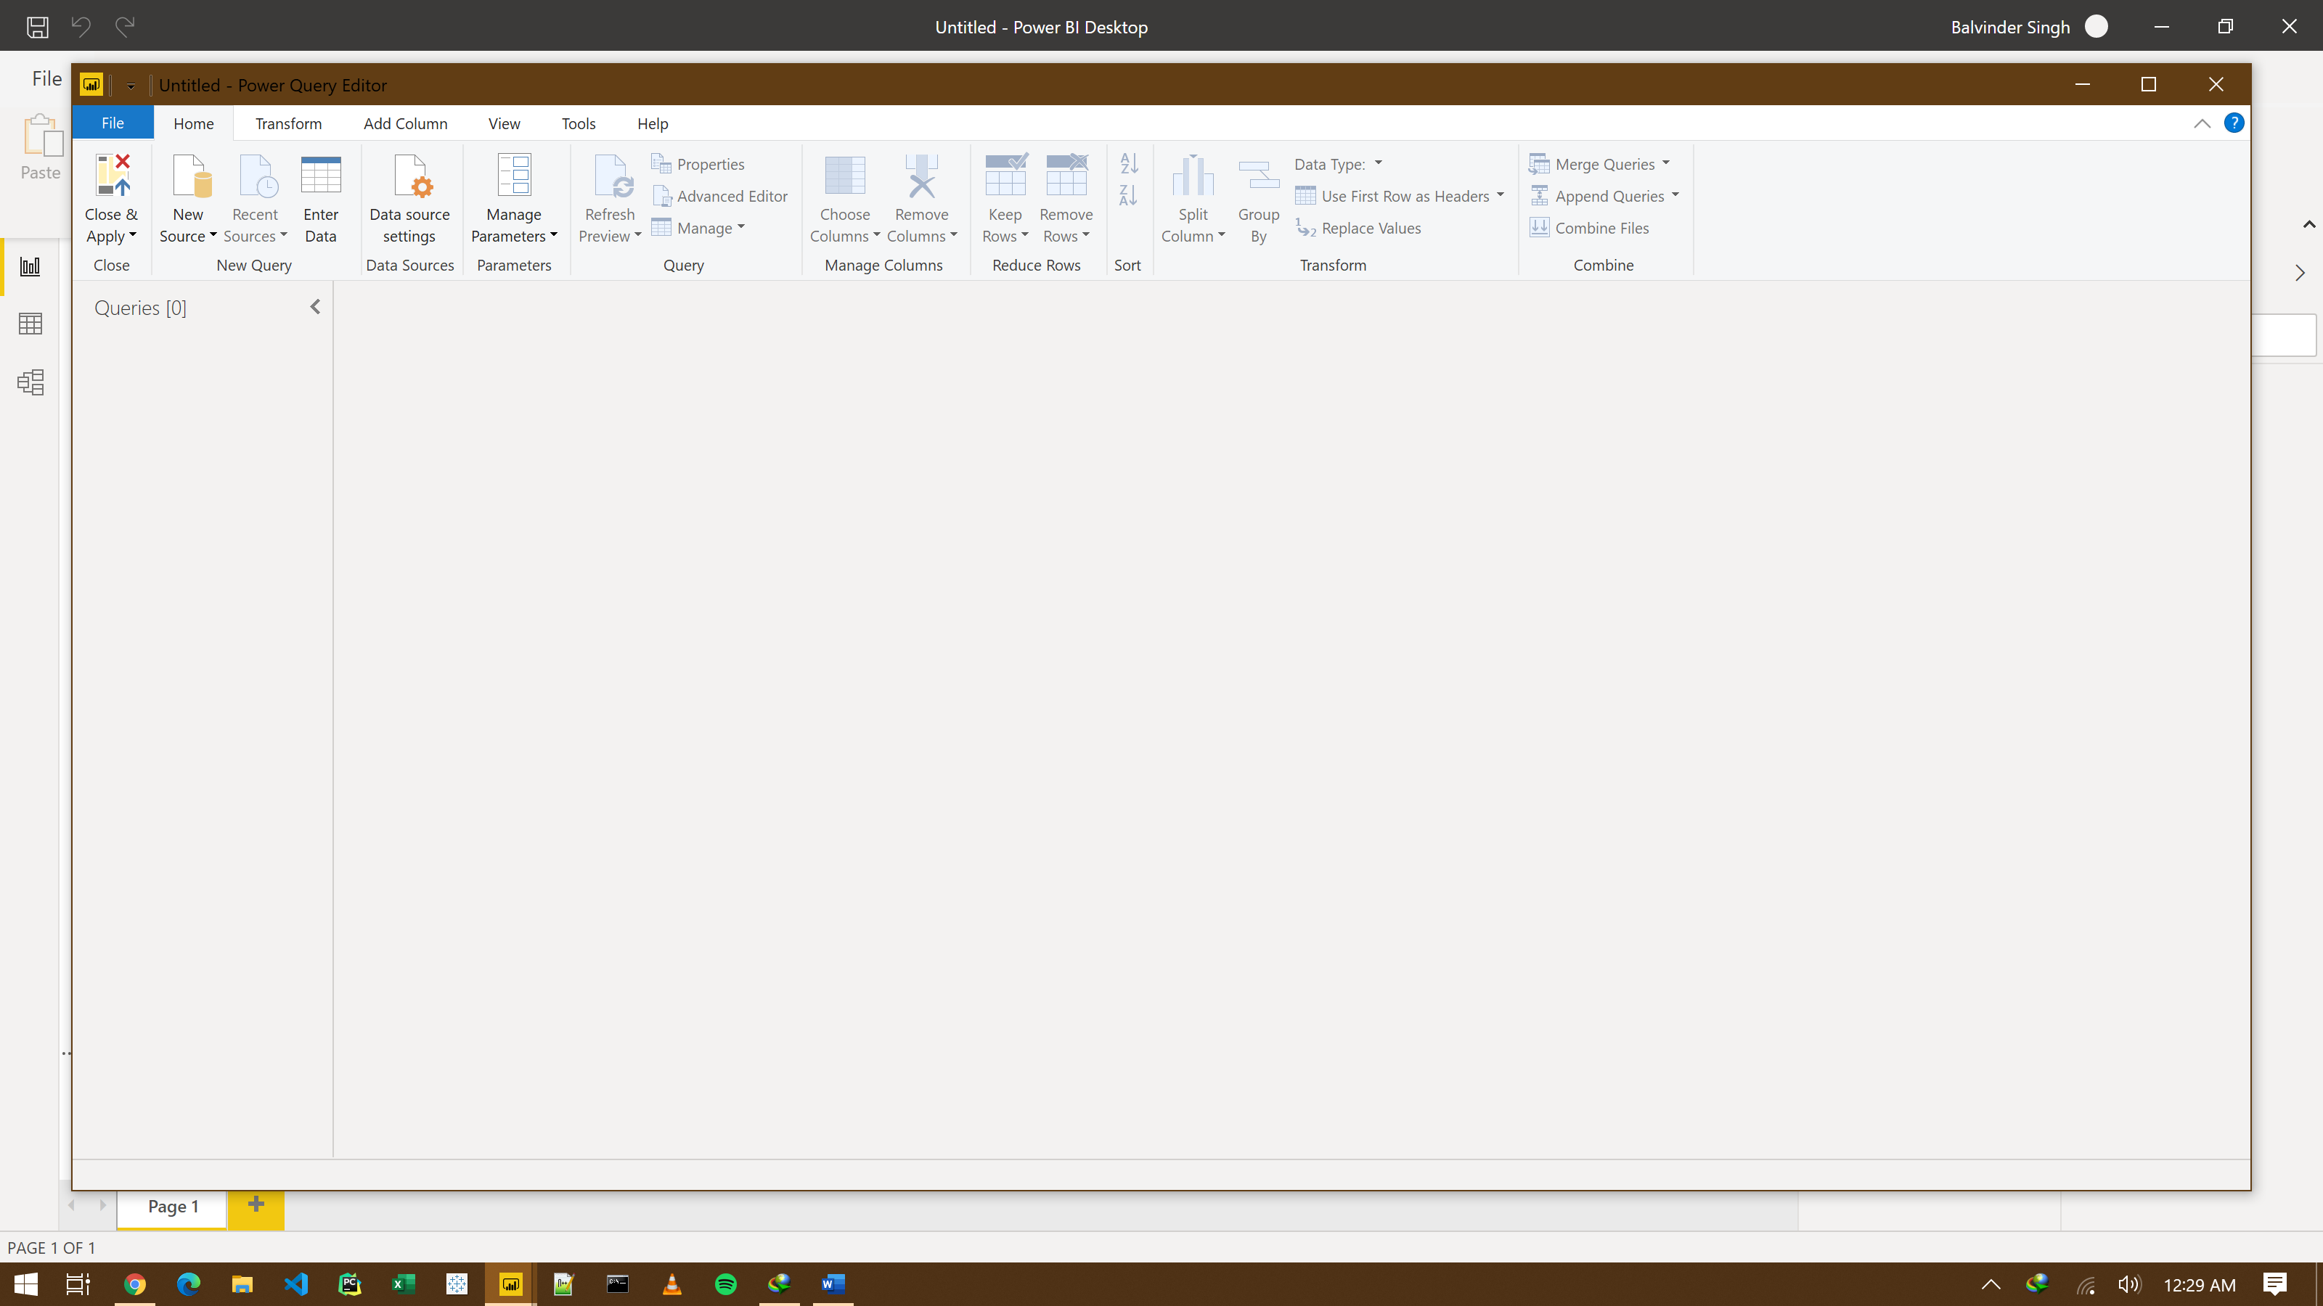

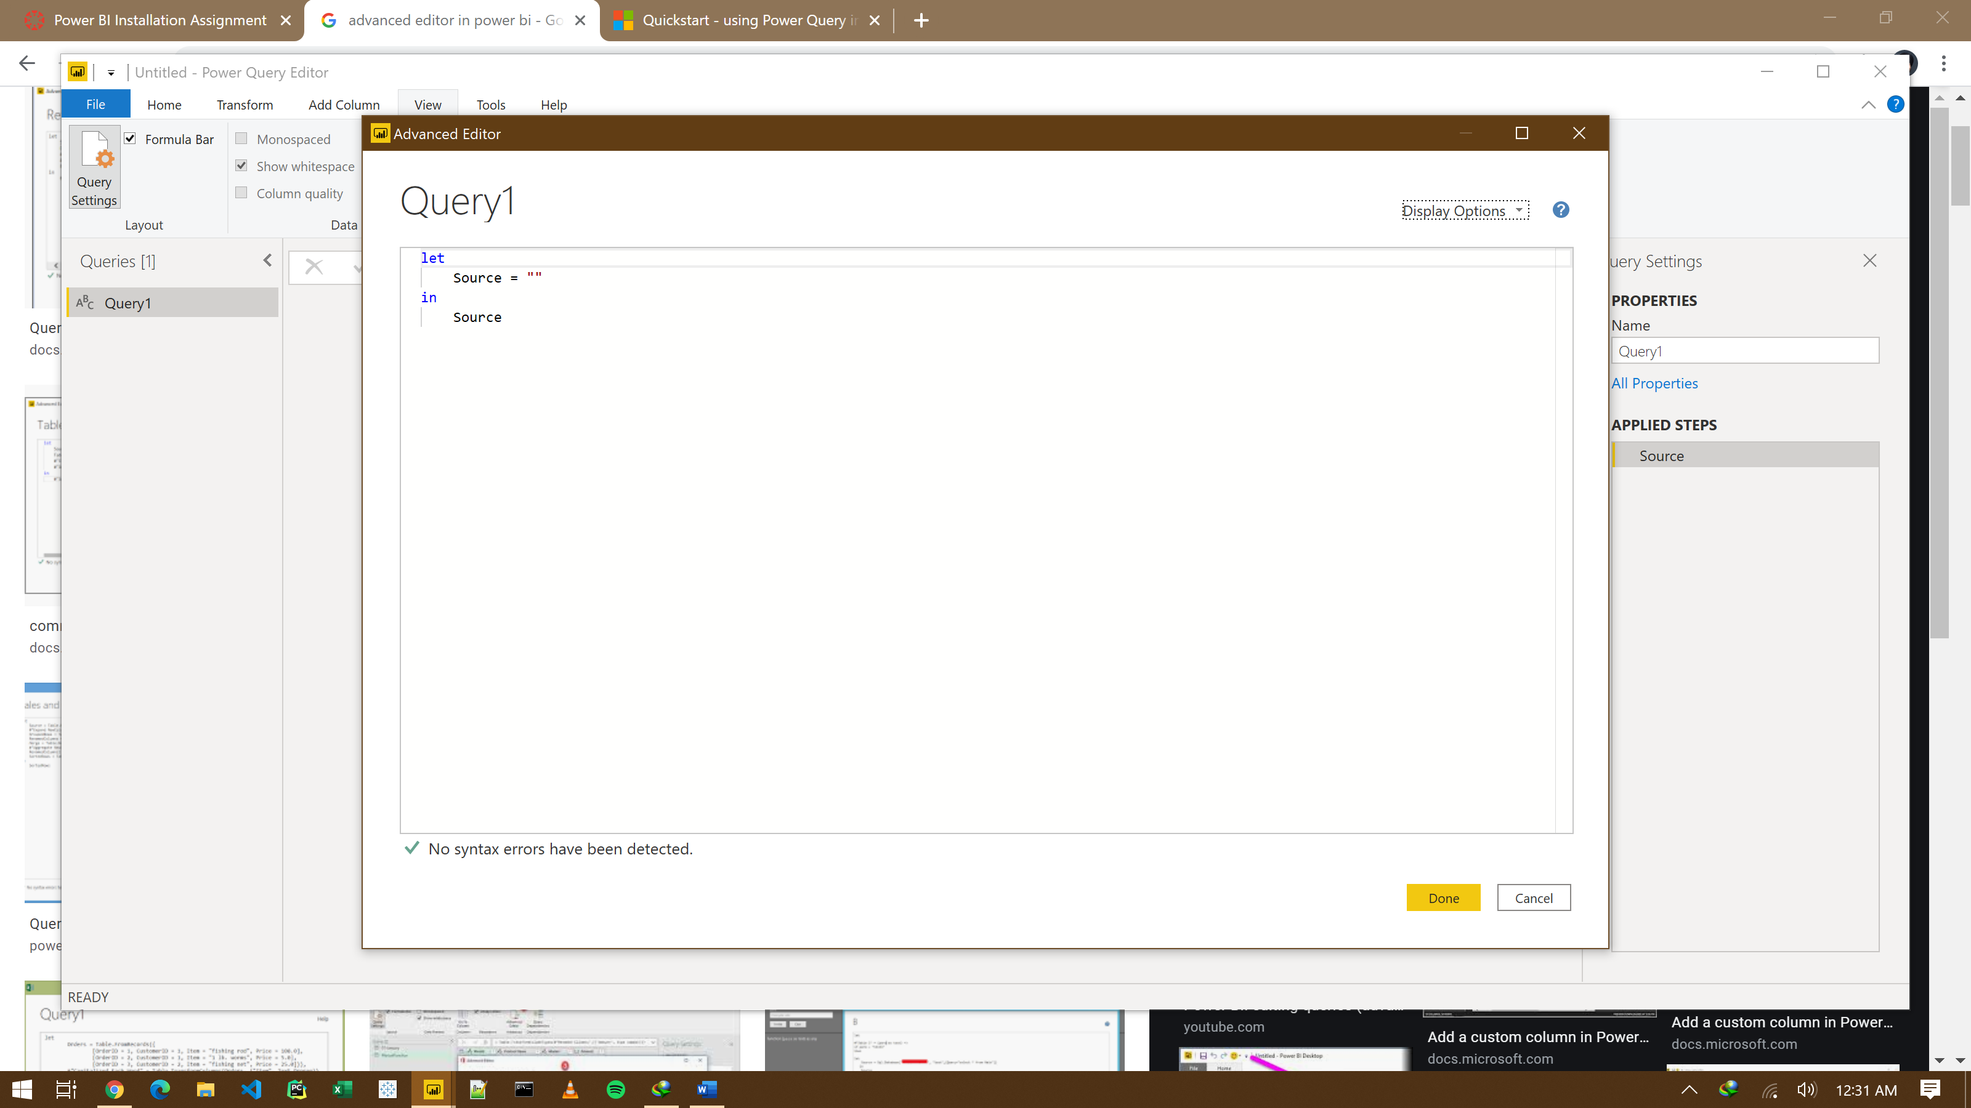

* Prepare a document with details of the following along with their price

− Power BI Desktop

− Power BI Pro

− Power BI Premium

